
e-ISSN : 2745-7206
http://iontech.ista.ac.id/index.php/iontech

AUTHOR FORM
IONTech Journal of Engineering and Pharmacy

Manuscript Title:
Corresponding Author’s Phone/WhatsApp Number:
First Author:
1. Name : ............................................................
2. Affiliation : ............................................................
3. E-mail : ............................................................
4. Orcid ID : ............................................................
Second Author:
1. Name : ............................................................
2. Affiliation : ............................................................
3. E-mail : ............................................................
4. Orcid ID : ............................................................
Subsequent Authors:
1. Name : ............................................................
2. Affiliation : ............................................................
3. E-mail : ............................................................
4. Orcid ID : ............................................................

IONTech Journal Requirements:
The manuscript submitted to the IONTech Journal must consist of original research that has not been previously published in any other journal. Authors are also required to complete this Author Form when submitting their manuscript.

MANUSCRIPT TITLE
(Center, Times New Roman 14, Uppercase, Bold)

The manuscript title must be brief, concise, specific, and informative in accordance with the theme of the article. The title should not exceed 20 words, written in uppercase letters (ALL CAPS), Times New Roman font, 14 pt size, bold, centered, and single-spaced.

Example Title :
FORMULATION OF CREAM DOSAGE FORM OF 70% ETHANOL EXTRACT OF BAMBU APUS LEAVES (GIGANTOCHLOA APUS) AS A SKIN MOISTURIZER

Author^{1*}, Author², Author³, Author⁴, Author^{N}
(Full name without academic degree, Center, Times New Roman 12, Bold. The corresponding author is marked with an asterisk.)
¹Name of Institution [center, Times New Roman 11, Capitalize Each Word]
²Name of Institution [center, Times New Roman 11, Capitalize Each Word]
³Name of Institution [center, Times New Roman 11, Capitalize Each Word]
⁴Name of Institution [center, Times New Roman 11, Capitalize Each Word]
^{N}Name of Institution[center, Times New Roman 11, Capitalize Each Word]
(Center, Times New Roman 11, Capitalize Each Word.
The institution name may include address, city, postal code, and country.)
*Correspondence: correspondingauthor@email.com

Abstract [center, Times New Roman 12, bold]

Abstract must be written in Bahasa and English, in single paragraph and not more than 250 words. Abstract contains clear statement of the objective, methods, results, and conclusion. [Justify, Times New Roman 10, line spacing single]

Keywords: should be written in not more than 5 (five) words and listed alphabetically. [Justify, Times New Roman 10, line spacing single]

INTRODUCTION [TNR, 12pt, Bold, line spacing 2, UPPERCASE]

Contains background and objectives (objectives should be stated at the end of the paragraph); written efficiently and supported by other and recent references (to strengthen the research). The research objectives must be clearly stated. [Times New Roman 12, justify, double line spacing, two-column format]

METHODS [Times New Roman 12, Bold, Uppercase]
Materials and Instruments [Times New Roman 12, Bold, Capitalize Each Word]

Materials and instruments that are the main focus of the study should be listed, including the product name, purity, and brand (example: H₃BO₄ 2% (Merck), micropipette (Thermo Scientific Vantaa)). [Times New Roman 12, justify, double line spacing]

Research Methods [Times New Roman 12, Bold, Capitalize Each Word]

The research methods (procedures, experimental design, and data analysis) must be written clearly and presented in subsections according to the research methods used. If the procedure is standardized, it is sufficient to only cite the reference. [Times New Roman 12, justify, double line spacing]

Ethical Approval And Informed Consent
[Times New Roman 12, Bold, Capitalize Each Word]
This study was approved by the Research Ethics Committee of [Institution Name] (No: [Ethical Approval Number]). Informed consent was obtained from all human participants prior to their participation in the study.
For studies not involving human participants or experimental animals, authors must explicitly state that ethical approval and informed consent were not required.
[Times New Roman 12, justify, line spacing double]

RESULTS AND DISCUSSION [Times New Roman 12, Bold, Uppercase]

Results and discussion are presented separately, consisting of the Results and Discussion subsections. Research data should be presented in the form of tables, graphs, or figures accompanied by data interpretation to facilitate readers’ understanding of the study. Tables, graphs, and figures must be numbered according to proper academic conventions.
The citation of tables, graphs, and figures must correspond to their numbering (example: “…the results in Table 1 show that…”). Figures must be in 300 dpi resolution in TIF or JPEG format. Tables and graphs must be provided in Microsoft Excel format (.xls or .xlsx). Decimal numbers in the text should be written using a comma (,).
(Times New Roman 12, justify, double line spacing)

Subsection Results and Discussion (etc.) [Times New Roman 12, Bold, Capitalize Each Word]

Results (Times New Roman 12, Bold, Capitalize Each Word)

This section only contains the research data obtained, presented concisely, clearly, and systematically in the form of text, tables, graphs, or figures. No extended analysis is included, only descriptive explanations.
Discussion (Times New Roman 12, Bold, Capitalize Each Word)

This section discusses the meaning of the research findings, relates them to theories, compares them with previous studies, and explains the strengths, limitations, and implications of the research.

Table 1. Sunscreen cream formulation (Times New Roman 12, Center, Sentence case, Single line spacing)

Ingredient | F0 | F1 | F2 | F3
Ingredient | %
Oil phase
Stearic acid | 3 | 3 | 3 | 3
Cetyl alcohol | 1 | 1 | 1 | 1
Emulgide | 5 | 5 | 5 | 5
Fase airAqueous phase
Propylene glycol | 5 | 5 | 5 | 5
Glycerin | 6 | 6 | 6 | 6
TEA (Triethanolamine) | 1 | 1 | 1 | 1
Distilled water | ad. 100 | ad. 100 | ad. 100 | ad. 100
Additional ingredients
Methyl paraben | 0,2 | 0,2 | 0,2 | 0,2
Rumput laut  (Kappaphycus alvarezii) | - | 5 | 7,5 | 10
Yam powder  (Pachyrhizus erosus) | - | 10 | 7,5 | 5
Notes: if necessary (Times New Roman 10, justify, single line spacing)

Mathematical formulas should be written using the Equation tool.
Notes: if necessary (Times New Roman 10, justify, single line spacing)

Notes: if necessary (Times New Roman 10, justify, single line spacing)

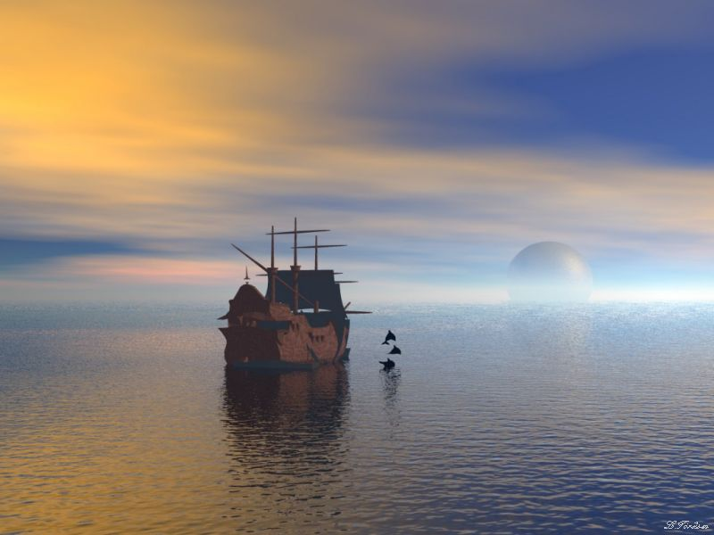

Figure 2. Image results remark (Times New Roman 12, Center, Sentence case, Single line spacing)

CONCLUSION [Times New Roman 12, Bold, Uppercase]

This section provides the answer to the research objectives and not a summary of the results obtained. The conclusion should be written in one paragraph.(Times New Roman 12, justify, double line spacing)
UCAPAN TERIMA KASIH [Times New Roman 12, Bold, Uppercase]

This section (if any) is used to express gratitude to funding sponsors or parties (institutions/individuals) who have collaborated or contributed. (Times New Roman 12, justify, double line spacing)
REFERENCES [Times New Roman 12, Bold, Uppercase]

Abernethy, D. R., Gutkowska, J., & Winterbottom, L. M. (1990). Effects Of Amlodipine, A Long-Acting Dihydropyridine Calcium Antagonist In Aging Hypertension: Pharmacodynamics In Relation To Disposition. Clinical Pharmacology And Therapeutics, 48(1), 76–86. Https://Doi.Org/10.1038/Clpt.1990.120
Andersen, S., Tarnow, L., Rossing, P., Hansen, B. V., & Parving, H.-H. (2000). Renoprotective

Effects Of Angiotensin Ii Receptor Blockade In Type 1 Diabetic Patients With Diabetic Nephropathy. Kidney International, 57(2), 601–606. Https://Doi.Org/10.1046/J.1523-1755.2000.00880.X
Reference Guidelines
- Font & Style
References must be written in Times New Roman, 12 pt, normal.
- Number & Composition
- A minimum of 10 references is required.
- At least 80% must be primary sources (reputable international/national journals, patents).
- The remaining references may consist of books, proceedings, or official reports.
- Order & Year
- References must be arranged alphabetically based on the author’s last name.
- References should preferably be within the last 10 years from the submission date, especially for recent research and theories.
- Exceptions apply to fundamental methods/theories, which may exceed 10 years.
- Source & Author Identity
- Only references with clear author identity are allowed.
- Anonymous sources or unofficial websites are not permitted.
- Writing System & Application
- Use reference management applications such as Mendeley, EndNote, or Zotero.
- Citation style must follow the American Psychological Association (APA), 7th edition.
- Only references cited in the text should be listed in the reference section.

